Grace Ntes

May 2026
A MONTHLY NEWSLETTER

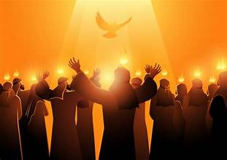

Grace Episcopal Church
41 Bowman Street
Mansfield, Ohio 44903
www.gracemansfield.org

Our Mission:
“To Nurture our Members and Feed our Neighbors”

Along the Way . . .
Let Peace Begin with Me


I remember the weight of the air in our living room on Sunday, November 20, 1983. I was just a frightened twelve-year-old boy, sitting between my parents as we tuned into ABC for the commercial-free premiere of the made-for-TV movie, The Day After. At the time, my parents felt it was vital for their children to see it; in the chilling climate of the Cold War, nuclear conflict didn't feel like a "what if," but a "when."
The images from that night stayed with me long after the screen went black: the blinding flashes of the explosions, the haunting silence of the radioactive fallout, and the visceral realization of how fragile our world truly is. The nightmares plagued me for weeks. Yet, out of that fear, a resolve was born. I vowed then that I would work for peace in our world—and I realized, even at twelve, that if peace was ever going to happen, it first had to begin with me.

A Day of Witness: April 19, 2026
Fast forward to this past Sunday, April 19. My day was bookended by two powerful vigils that reminded me that the vow I made in 1983 is more relevant now than ever.
In the afternoon, I had the privilege of taking part in the Annual Yom HaShoah Holocaust Day of Remembrance at Mansfield’s Historic Emanuel Jacob Synagogue. We gathered to honor the memory of the six million Jews and six million others who perished at the hands of the Nazis. It was a powerful statement to see Jews and Christians standing shoulder-to-shoulder—praying, sharing stories, and witnessing together to the power of being peacemakers.
Later that evening, at 7:00 p.m., I joined ecumenical colleagues at St. Matthew’s Episcopal Church in Ashland for a Vigil for Peace and for the People of Iran. Through prayer, meditation, and a "hard silence," we sat with the world’s current suffering and renewed our vow to be peacemakers in our own specific time and place.

Following the Prince of Peace
As followers of Christ, peacemaking isn't an optional hobby; it is our core vocation. Jesus was clear when He sat on the mountaintop and told the crowds:
"Blessed are the peacemakers, for they will be called children of God." — Matthew 5:9
Our former Presiding Bishop, Michael Curry, has long championed the "Way of Love" as the antidote to a world of division. He frequently reminded us that this work is rooted in the very nature of God’s love:
"Peace is not the absence of conflict; it is the presence of God’s love in the midst of it. When we seek to love our neighbor as ourselves, we are doing the hard, holy work of peacemaking."

Who Will, If Not Us?
We are living in a time of war instead of peace. We see neighbor turning against neighbor, nation rising against nation, and even within the Body of Christ, we see Christians turning against one another.
If we don’t pray and work for peace today, who will? Peace doesn't usually start with a treaty signed in a distant capital. It begins in our own homes, our churches, our workplaces, our schools, and our neighborhoods. It happens one person at a time, one intentional act of kindness at a time. We can truly be peacemakers in our day and time if we follow the Prince of Peace.
Let us carry this prayer in our hearts and make it our daily anthem: "Let there be peace on earth, and let it begin with me."
As we do so, along the way...
Peace and Blessings,
Fr. Christopher D. Hofer, Priest-in-Charge
Grace Moves Forward with “One Voice”
April Vestry Meeting Focuses
on Unity, Growth, and Stewardship
The Vestry of Grace Episcopal Church gathered on April 21, 2026, under a unifying theme: “One Voice.” Led by Fr. Christopher Hofer, the session focused on a commitment to shared spiritual formation and covenantal trust, ensuring that leadership remains transparent and coordinated as the parish enters a busy spring season.

A Flourishing Pantry Ministry
The pantry continues to be a cornerstone of Grace’s outreach to the community. Data from the first quarter of the year (January–March) reveals the staggering scale of this ministry:

• Households Served: 3,885
• Children Impacted: 2,008

To sustain this momentum, the Vestry identified several immediate needs, including the recruitment of more volunteers—specifically for cleanup duties and grocery transport during the midday hour (12–1 p.m.). Leadership is also exploring options for additional space to support the upcoming kitchen and bath pantry expansion.

Financial Health and Stewardship
The parish remains on solid financial footing as it prepares for the upcoming diocesan audit. Treasurer reports for March show a General Fund balance of $163,012.89 and a Pantry Fund balance of $112,051.90. The Vestry formally received the financial report and is working to ensure all documentation is ready for diocesan audit.
In property news, the Vestry turned its attention to the organ loft. Following reports of ongoing reliability issues with the church organ, leadership reviewed past repairs and acknowledged that a major rebuild may be necessary in the future. The Vestry affirmed the organ’s vital role in worship and will consult with experts to determine a sustainable path forward for the instrument.
Parish Life and Collaborative Worship
Grace’s liturgical life is thriving following a successful Easter season. Engagement in spiritual formation is growing, and several exciting initiatives are on the horizon:

• Lay Preacher Training: New opportunities for parishioners to deepen their involvement in the liturgy.
• Pentecost Eucharist: Fr. Hofer is coordinating with Fr. Sipes about serving at St. Matthew’s on Pentecost and Fr. Hofer would be at Grace.
• Pride 2026: Mansfield Pride is finalizing details for the Pride festival and parade, including an interfaith service which will once again be held at Grace.

Diocesan Updates
Questions regarding a Celebration of New Ministry were discussed. Senior Warden Jenny Blue will be following up with diocesan staff following the May clergy conference to provide the Vestry with further clarity.

Upcoming Meeting
The next Vestry meeting is scheduled for May 26 at 6:30 p.m. All parishioners are invited to keep our lay and clergy leadership in their prayers as they work with "One Voice" to serve our neighbors and our Lord.

Thank you to clergy, staff, and volunteers for their faithful service. With “One Voice” and shared purpose, Grace moves forward with hope for our ministries, our neighbors, and our music and worship life.

Our Friday noon Bible study continues to explore the Wisdom Books through a contemplative, Anglican lens. Each session blends Scripture, discussion, and gentle reflection every Friday at 12:00 p.m. in the Sipes Fellowship Hall or you can join us via Zoom.

We recently began exploring the Psalms as prayers that hold the full range of human experience — trust, lament, waiting, and hope. Today, we’ll continue that journey together as we spend time with another Psalm and reflect on how these ancient prayers meet our lives today.

All are welcome—whether you’ve been part of the fall sessions or are joining for the first time. All you need to bring is a Bible. Questions? Contact Jenny Blue at 419-612-6813.

Breaking Bread Together
Making Sense of the Holy Eucharist
in the Episcopal Tradition

Grace Episcopal Church and Pantry invite parishioners and guests to a five-week Christian Formation series in May: Sundays, May 3, 10, 17, 24, and 31, 2026, 9:00–9:45 a.m. at the parish hall.
This interactive program—will help participants explore the meaning, history, and life-shaping power of the Holy Eucharist in the Anglican/Episcopal tradition. Using Scripture, Tradition, and Reason (the Anglican “three-legged stool”), participants will learn why we gather at the Lord’s table, how the Book of Common Prayer shapes worship, different theological ways Christians understand the presence of Christ, and what open communion and hospitality look like in practice. The series closes by connecting the table to service, including our pantry ministry.
Each 45-minute session follows the same structure: a short opening prayer, a simple icebreaker, focused teaching, small-group reflection, and a closing prayer. Weekly themes:
- May 3 — Why We Gather: Biblical Roots of the Eucharist
- May 10 — Tradition: How the Church Remembers (BCP & liturgy)
- May 17 — Reason & Theology: What Happens at Communion?
- May 24 — Open Communion & Hospitality: Who Is Welcome?
- May 31 — Living the Eucharist: Liturgy, Prayer, and Service

Midweek Mending

Our Healing Mass (Midweek Mending) is celebrated in the Chapel at 9:00 a.m. each Wednesday, concluding by 9:45 a.m. Please arrive a few minutes early if you can.
Each Wednesday we will gather for the prayers and lessons appointed for the day, hear a brief homily, and celebrate the Holy Eucharist. There will be opportunity for the laying on of hands and anointing with holy oil for healing of mind, body, and spirit. Fr. Christopher, Priest‑in‑Charge, and Fr. Daniel, Priest Associate, will lead the service and offer pastoral prayer and care.

The service is timed to finish before Food Pantry setup but is open to everyone—parishioners, pantry volunteers and guests, neighbors, coworkers, those on the margins, the sick and suffering, people struggling with addiction, the lonely, and anyone who wishes to pray.


2nd Tuesday of the Month
noon
May
Black Dog Tavern
900 Comfort Plaza
Bellville
RSVP by April 12 by noon
to 419-651-9789 and please
put your name

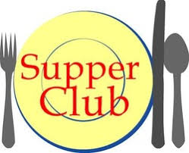
4th Tuesday of the Month
4:30 p.m.
May
Chinatown
283 Ashland Road, Mansfield


MAY BIRTHDAYS:

1 Kiersten Jones
Peggy Sipes
2 Ron Clinage
5 Michael Jones
James Mudra
13 Marcia Gagich
17 Dorothy
Duckworth
Jean VonBlon
19 Zetta Anderson
24 Touby Bender
MAY ANNIVERSARIES:

13 Fran & Jack Welch
27 Dorothy & Phil Duckworth
Carol Loveless
29 David Harmon
30 Paul Landin
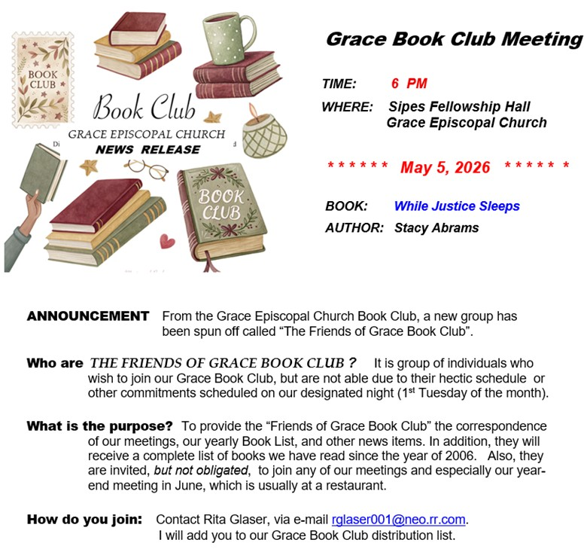
Annual Clergy Conference

Fr. Christopher and Fr. Daniel will attend the annual Diocese of Ohio Clergy Conference, May 19–21, at the Lodge at Geneva-on-the-Lake. This yearly gathering is a time for clergy to step away from daily ministry rhythms to pray, reflect, and renew our shared life in the diocese.
This year’s theme centers on the stories that shape us and how those stories shape our proclamation of the Gospel. Leaders from Backstory Preaching — The Rev. Dr. Lisa Cressman and The Rev. Monique Ellison — will guide participants in exploring their Preacher’s Backstory: the often-unspoken narratives that influence how we preach and live out the Gospel.
Through lectio divina with Scripture and with the stories of our own lives, clergy will deepen awareness of how God is at work in and through them for their own spiritual growth and for those they serve. The conference will combine practical formation and prayer, with opportunities to:
- pray and reflect on Scripture and personal stories
- engage in guided dialogue and holy listening
- examine links between spirituality and proclamation
- rediscover authenticity, courage, and joy in preaching
- rest, worship, and strengthen life together as clergy

The conference begins Tuesday, May 19 at 2:00 p.m. and concludes Thursday, May 21 at 12:00 p.m.
Please hold Fr. Christopher and Fr. Daniel in your prayers as they gather with colleagues for renewal, formation, and shared ministry.



Celebrate the Birthday of the Church
Sunday, May 24

On Sunday, May 24, Grace Episcopal Church and Pantry will mark Pentecost with worship at 8:00 a.m. and 10:00 a.m. Together we will remember the giving of the Holy Spirit and celebrate what many call the birthday of the Church. All are welcome—please wear red if you have it to honor the fire of the Spirit.

What is Pentecost?
Fifty days after Easter, the Church remembers the day the Holy Spirit came upon the apostles and early followers of Jesus, empowering them to speak, serve, and bear witness in new and courageous ways. Pentecost is both a historical moment and an ongoing promise: the Spirit continues to enliven, guide, and unite the body of Christ.
Why this matters at Grace Episcopal Church and Pantry
At Grace, Pentecost reminds us that our worship and our work are joined by the same Spirit. The Holy Spirit inspires our prayer, strengthens our fellowship, and sends us into the community to serve. For the Pantry, this day underscores our mission—serving neighbors with compassion, hospitality, and justice is a Spirit-led expression of faith. Pentecost calls us to be bold, generous, and open-hearted in ministry.



Dawn’s Debt: Memorial Day, 2026
Author Unknown

Beneath the hush of morning flags we stand,
Names folded into wind, into the light—
Each soul a candle passed from hand to hand,
Each life a map that led through darkest night.

They gave the dawn so others might sleep on,
Their laughter buried deep in fields of grain;
We keep their memory bright when they are gone,
And speak their courage softly, not in vain.

Let not their silence be the spark for more
But fuel for seeking ways to end the war—
To heal the borders where our children play,
To trade the gun for gardens, fear for day.

Remembered not as trophies, but as trust:
That peace is forged from justice, brave and just.
We pledge our hearts where once their hearts were spent—
To honor them, and labor for consent.

Renewal and Rest
Fr. Christopher Hofer to Attend CREDO 435

Fr. Christopher Hofer will be attending CREDO (Clergy Reflective Educational Discernment Opportunity) 435 at the Claggett Episcopal Center in Adamstown, MD, June 2–8. Sponsored by the Church Pension Fund, CREDO is a seven-day, Christ-centered renewal program that supports clergy wellness across spiritual, vocational, financial, and physical/psychological areas. This will be Fr. Hofer’s third CREDO conference (he previously attended in 2004 and 2011).

CREDO brings clergy together for worship, prayer, large-group plenaries, workshops, small-group conversation, one-on-one reflection, and time for rest, exercise, and renewal. Participants explore identity, discernment, practice, and transformation, and leave with a personal CREDO Rule of Life — a concrete covenant to sustain their faith, family, and ministry.

“CREDO has a way of returning me to the heart of my calling — it helps me listen again, rest, and form a concrete Rule of Life that keeps my faith, family, and ministry healthy. Every time I go, I come back more grounded, more hopeful, and better able to serve,” says Fr. Christopher Hofer.

Please keep Fr. Hofer in your prayers as he takes this time for reflection and renewal. We look forward to his return and the renewed energy and insight he will bring to our parish.
Greater Grace
Putting our Faith in Action in A New Way

First Christian Church is partnering with Grace Episcopal to open a Kitchen and Bath Pantry Ministry for people in need coming to Grace Food Pantry. The new Kitchen and Bath Pantry will be housed at First Christian Church. We are currently asking for "Gently Used" pots, pans, toasters, crockpots, skillets, dishes, glasses, silverware, along with dish rags and towels for the kitchen, and bath towels and wash clothes for the bathroom.

We are asking if anyone who crochets, knits or quilts, might consider making some pot holders and/or dish rags for the kitchen items. Also, anyone interested in volunteering please let me know

To Donate
Those wishing to donate items for the new pantry may drop them off at First Christian Church Fellowship Hall door (back side of the church off Dickson Ave) on Thursdays between 9 am and 11 am starting April 30th.

To Use the Pantry
The Pantry will then be open on the first and third Thursdays, starting May 7th, between 9 am and 11 am. Shoppers will be coming from Grace Food Pantry, and entering the Pantry through the Bowman Street door. Starting in May donations can be dropped off at the Bowman Street door at the same time the new pantry is open.
Should you have any questions, please feel free to give me a call at 614-333-9647.
Blessings, Deacon Beth
John Todd Park Clean-Up

A huge THANK YOU to our incredible team of 13 volunteers from our partnership between Mitchell Chapel AME Church and our own Grace Episcopal Church who helped clean up our adopted Mansfield John Todd Park. The team collected 16 large bags of trash.
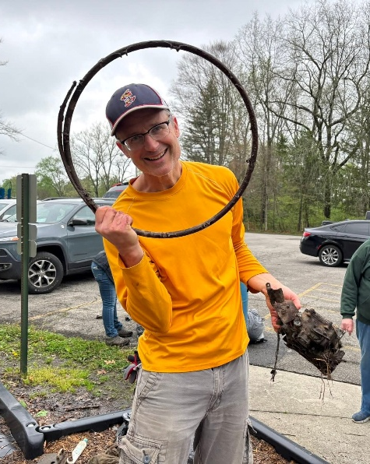
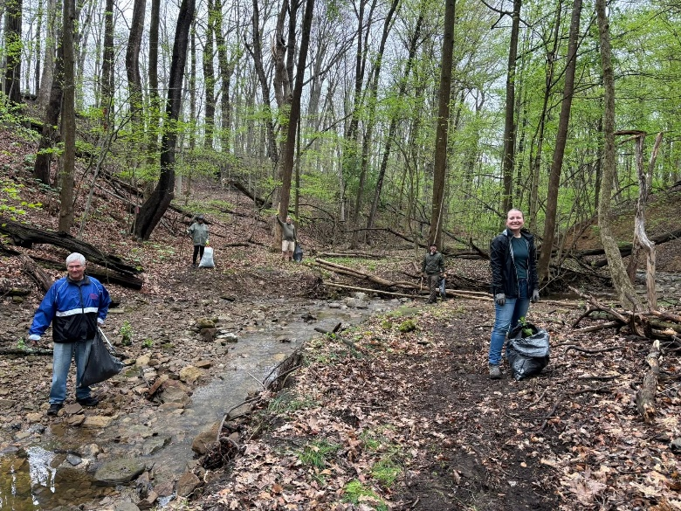

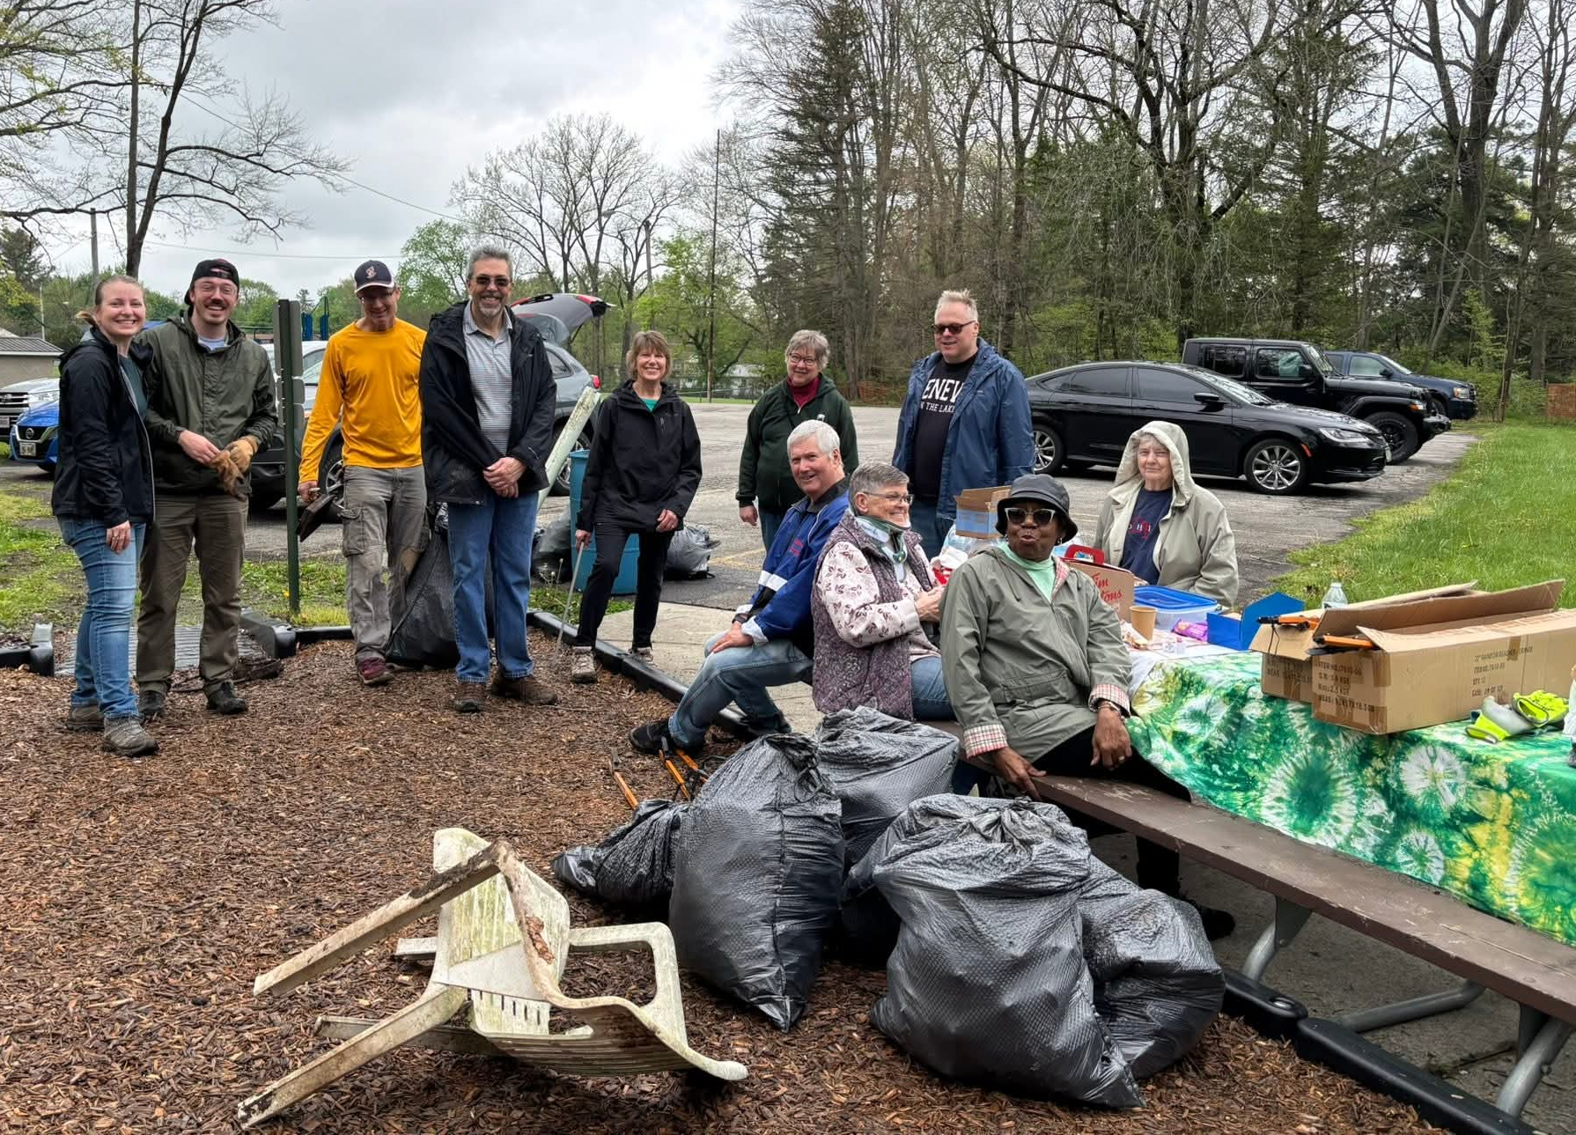



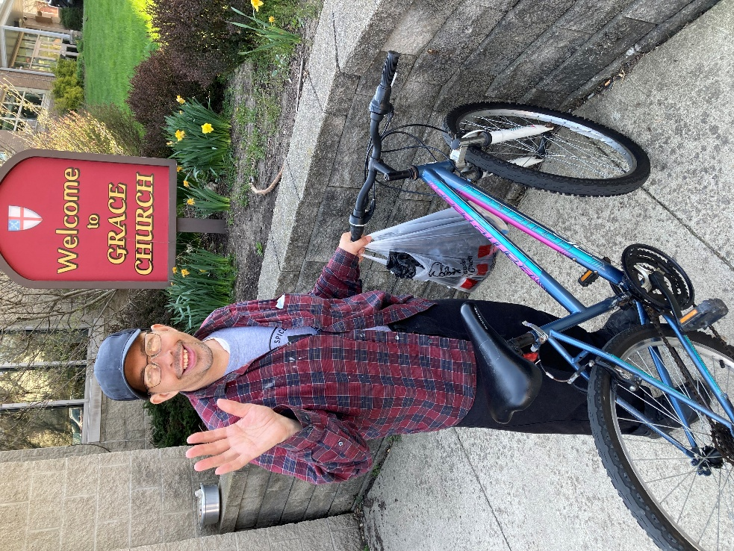
Joe has come to the pantry for many years. All of those years he has worked in fast food. He grew up Catholic but now is very happy in a Pentecostal church on Trimble. His bike was stolen.
Greg Collins coordinated with Joe and Pantry Pedals to get him a bicycle just a week after he applied.
Joe wrote on his application that a bike would help him, "get back and forth to work, to church and to visit my mom."
Joe also wrote, "sometimes I have to ride the bike to Walmart Ontario when the bus don't go on the weekends. It will help a lot, Thank You, Joe"
I am very grateful to Greg for making the process work more smoothly, grateful to Joe for his smile and dedication to his work, mother and church. We get to know some great people at the pantry.
Joe and his new bike
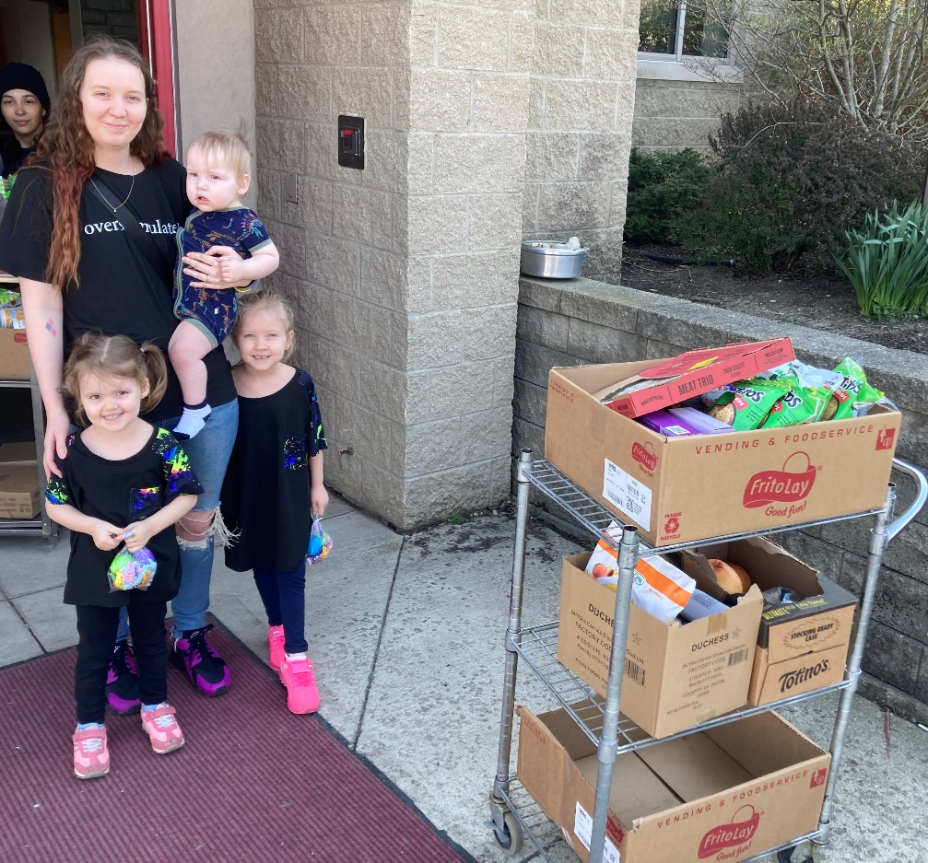
We hadn't seen Abbey for seven years, until she recently showed up with her three beautiful children. A bus driver from the DR found us. She came for the first time, and had a fantastic spirit about her.
Abbey and her three children


Then there was the home health aide who had taken her patient for testing, and stopped me in the hospital with a smile that lit up the sterile hallway and my day. Or, how about volunteer Niki, who after 11 years of encouragement is going to get her GED.

Did you know?

We had 1398 households in March

– just under a thousand, 950, children were in those households.

And then there’s “The People’s Mayor!” People go through a lot in life. The pantry is a filter for remarkable folks. As Vinyl wrote, "Hunger isn't only a physical ache. It's an ache to be seen, welcomed and
told, "There's more than enough -- We serve from
gratitude. Not as charity. But
as communion."

May we live their words for us.
Peace,
Daniel
Events Around the Diocese

May 6

Join St. Barnabas, Bay Village for an ecumenical Celebration of Hymns on May 6 at 6:30 p.m. Churches from across Bay Village will gather for an evening of prayer, scripture, and song. Together, we’ll sing beloved hymns from our various faith traditions—celebrating the rich ways we offer praise to God. A combined community choir will lead us in this powerful reminder of our common faith. This event is free and open to the public.

May 7

The Prayer Life Team of the Episcopal Church Women (ECW) of the Diocese of Ohio is offering an online event for this year's National Day of Prayer on May 7. The session starts at 7:00 p.m. and will last about 40 minutes. Registration for the ECW's National Day of Prayer gathering is available here. For questions about this event, reach out to the ECW Prayer Life team.

May 15

Join All Saints, Parma on May 15 at 7:00 p.m. for Vocalist Minkyeong Kim with a reception to follow in the Parish Hall. This concert is free to the public - please invite your friends, family, neighbors, coworkers, etc.! A free-will donation will be taken to support the All-Saints Music Program.

May 24

Join us Grace Church, Sandusky on May 24 at 4:00 p.m. for a special organ recital by Dr. David Saunders. A highly accomplished musician, Dr. Saunders has performed across the Midwest and internationally, including appearances in France and holds advance degrees in organ and church music from institutions such as the University of Michigan. With decades of experience as an organist, choir director, and educator, he brings both technical mastery and deep musical expression to his performance. Admission is free, with a freewill offering gratefully accepted. All are welcome to come and enjoy an afternoon of inspiring music.

Grace Church Ministry/
Organizational Tree

Vestry

Jenny Blue – Senior Warden
Deb Landin – Junior Warden
Joanne Mudra – Secretary
Larry Von Blon – Treasurer

Betty Diemer
Rita Glasser
Matt Moser Miller
Joanne Mudra
Stephen Myers
Anne Stump
Jason Whitehead

Staff

Pam Armstrong, Church Administrator, gracechurch41@yahoo.com
Lori Turner, Director of Music
Thomas Palmer, Organist
Michael Blue, Sexton
Tom Dornbusch, Social Media Coordinator

